
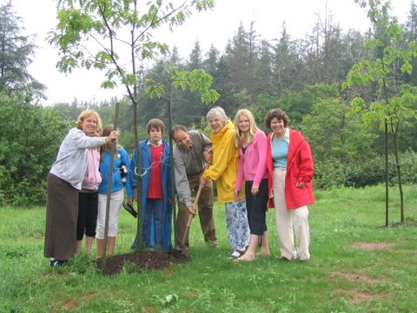
If giving is one of the family values you want to pass along, we can help your family build a tradition of giving.

Community Builders are people who are interested in making Prince Edward Island an even better place to live – both for this generation and generations to follow. Community builders want to give back to their community and want to start doing it now. Community builders are thinkers, planners, and doers in all walks of life. They realize that their successes resulted from help by many people and, through establishing a legacy fund, they can say thanks while making the community a better place for others.

What do Community Builders do?
Community Builders can be recognized by what they do, even though all community builders do not do the same thing. Some build quietly and out of sight, others build publicly; most have a passion whether for the environment, heritage, education, health, religion, or the general welfare of friends and neighbours. They are active in volunteering, contributing, leading, supporting and giving. They help out today but also think about tomorrow. They also set aside funds to support their passions even when they are no longer here to do so.

What is a Community Builder Fund?
A Community Builder Fund is an endowment the income from which is available in perpetuity to support good works and causes identified by the community builder. Such endowments may be created at the time of death; however, increasingly community builders participate in both the planning and building of an endowment while they are still alive. In this way, they can participate in the design of their legacy and the decision-making as to which causes gifts may be given. Community builders also may, if they so desire, continue as advisors to their investments even after assigning ownership to CFPEI.

Becoming a Community Builder is easy -

START TODAY :

- talk to someone at the Community Foundation about your interests and options available
- choose a path to reach your goal
- enter into a simple agreement with the Foundation setting out the name, purpose of the fund, annual contribution and the specified contribution period
- make your first payment

The Community Foundation of
Prince Edward Island
119-121 Quen Street, Suite 105
Charlottetown, PE C1A 4B3

Telephone: 902-892-3440
E-mail: www.cfpei.ca

“CONNECTING PEOPLE WHO CARE WITH
CAUSES THAT MATTER”

BE A
COMMUNITY BUILDER

“I am impressed with the ability of the Foundation to design funds that reflect both the donor interests and community needs”
Dr. Thomas Hall
La Fondation ommunautaire de l'Île-du-Prince-Édouard
Place Queen Square
119-121, rue Queen
Charlottetown, Île-du-Prince-Édouard
C1A 4B3
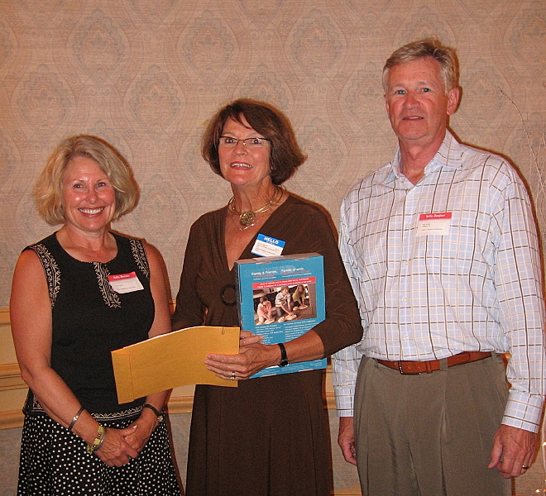
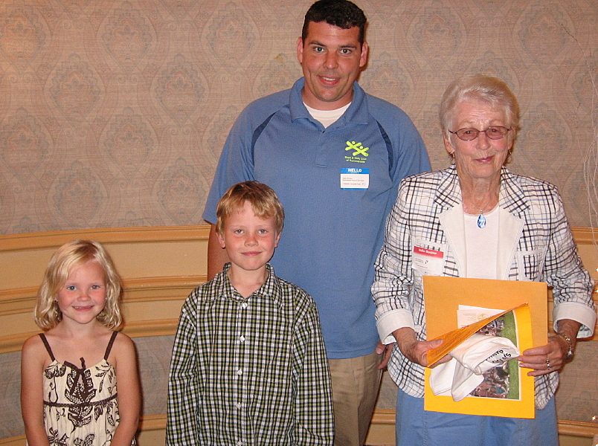
Ten reasons people choose community foundations.
one
We are a local organization with deep roots in the community, and part of a nationwide movement whose support we build and share.
two
We bring donors to the table as community builders, working closely with them to align their philanthropic vision with the community’s needs.
three
We identify long-term needs and opportunities and invest in solutions that let our communities guide their own future.
four
We take a broad and inclusive view of what a community is, and provide grants to the widest possible range of organizations and initiatives.
five
We provide highly personal and flexible service, accepting a wide variety of assets and offering donors maximum tax advantage.
six
We build permanent funds and those that can respond to immediate needs, helping our communities ensure vital futures.
seven
We multiply the impact of gift dollars by pooling them with other gifts.
eight
We believe that diversity is strength, so we bring the entire community together to stimulate new ideas, build participation and strengthen community philanthropy.
nine
We are transparent and reputable stewards of community resources, committed to being accountable, accessible and responsive.
ten
We build community vitality – the unique and essential spirit that flourishes when people believe their community holds possibilities for everyone.
Board of Directors

John Robinson
Tom Davies
Joyce Gaudet
Tracey Laughlin
Don Glendenning
Rod Nicholson
Steve McQuaid
Carol Fraser
Rogers Bell
Andrew Daggett
Stanley MacDonald
James Travers

The Community Foundation of Prince Edward Island (The Foundation) is dedicated to improving the quality of life for all Islanders. We are a local organization with deep roots in the community, however we are part of a nationwide network, one of 168 in Canada.

Currently, The Foundation administers 50 funds with a value at almost $1.3 million. In a typical year, The Foundation provides grants in excess of $60,000 to Island charitable organizations such as the QEH, CPR Anytime (Heart & Stroke), library books for the improvement of reading, transportation for the disabled, scholarships, support of youth athletics and initiatives such as SAVE (Students Against Violence Everywhere), environmental, counseling, Home Heating Program, etc.

The Foundation is committed to creating value within the charitable sector; we are experienced in designing and administering endowments throughout the Island in all charitable sectors. We are proud of our record as stewards of community charitable resources (the charitable dollar) and operate in an open, transparent and responsive manner. Our services are open to you without cost as you think about your charitable legacy.

Wilma Hambly, Heart & Stroke (PEI Division) accepts a grant from the David A. MacKay Endowment Fund. Presenters are Debbie and Phil Grubbe.
The Boys and Girls Club of Summerside were recipients of a grant from the
J. Melville Campbell Endowment. Mary Campbell accepts a thank you from members of the Boys and Girls Club from Summerside.

